2018 CNYBAC Medical Device Innovation Challenge (MDIC) Selected Teams

Location: Massachusetts  Team Members: Mary-Kate Reid, Mike Reid, Jimmy McNamara | Sea Legs has designed a waterproof AFO with specialized features in response to patient needs to increase mobility for individuals with bone abnormalities by improving the Ankle-foot orthosis (AFO). Children and adults with certain medical concerns wear AFOs which can correct the way individuals walk or prevent bones from breaking and most must wear the AFOs at all times. The problem, especially for children, is that exercising in water is recommended as a safer alternative for patients and the current use AFO is time-consuming to apply and is a bulky, heavy solution. Sea Legs has been recently been accepted as a Queen’s University, Mechanical and Materials Engineering Capstone Design Project. Queen’s University is a partner with CNYBAC through the Kingston Syracuse Pathway.
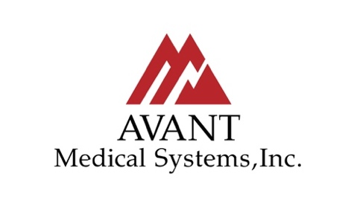  Location: Alaska  Team Members: Sheridan Heinrichs, CEO; Scott Hilton, Attorney. Advisory Board: Dan Grimes, Deputy Chief of Operations---Central Emergency Services, Soldotna, Alaska; Dr. Bethany V. Chernich, DO, ACOFP; Owen Park, Lead EMS/Search and Rescue Pilot Classic Air Medical, Kanab, UT; Scott Rice, Engineer; Adam Krynicki, Executive Director, Cascades Innovation Co-Lab. | Avant Medical Systems, Inc. is a medical device development company that has designed and patented a medical device that it plans to manufacture and market. The medical device will help medical professionals deliver better care that will reduce the number of medical errors and malpractice liability, while improving the quality of patient comfort and care. Avant Medical has been accepted as a Queen’s University, Mechanical and Materials Engineering Capstone Design Project. Queen’s University is a partner with CNYBAC through the Kingston Syracuse Pathway.
Location: Buffalo, NY  Company member: Wilfrido Mojica, M.D., Founder | Pathology cell processing start-up designed to address the problem of diminutive specimens and the ever-increasing amount of tests being required of them. Celltomic’s disruptive technology has the capacity to revolutionize personalized medicine laboratory methods.

Location: Rome and Syracuse, NY  Team Members: Evan Drozd, Nick Polosky | A subset team from ANDRO Computational Services is developing an innovative spinal medical device to support a self-learning, smart-assist stabilizer leveraging ANDRO’s AXLForce C4 AI software and machine learning technologies.
Location: Rochester, NY  Team Members: Adolf Akuffo-Afful, CEO; Khadijah Williams, VP of Design; Jake Wexler, CE; Nick Condello, CDO; O’nell Campbell, CME; Tracy Martini, COO; Mavis Nvodjo, CFO | Hive Refrigeration is a design firm creating technological solutions able to decrease the energy expenditure and monitor your mobile medical refrigeration capabilities. Their line of products is being created to solve issues around energy dependent, immobile and unmonitored temperature systems in current medical refrigeration units.
Location: Syracuse, NY  Team members: Kayla Simon and Elizabeth Tarangelo | In-Spire is a customizable sleek band that has a small inhaler integrated into it. The bracelet can be re-opened and refilled after each use, allowing for a sustainable and reliable product for consumers. Accessing the medication inside is as simple as opening the band and using the Bite Actuation Method, which is a novel process where the user uses their teeth to activate the flow of medication, rather than their hand (which is associated with many issues in receiving proper dosages due to hand to mouth coordination errors). This patent-pending product is entering the market at a time where wearable technology is becoming increasingly present, and adds a valuable medical component to wrist real-estate options to serve a vast market of people who don’t want to or forget to carry around the ubiquitous bulky standardized inhaler. The In-Spire team has recently incorporated as an LLC, has won $30k in business plan competitions, and is focusing on product development in compliance with FDA standards to move towards commercialization.

